|  |
| --- |
| **Industrial AI & Automation : Bearing Fault Diagnosis** |

Name : HanMinung

ID : 21800773

2023 spring semester

**1. Experiment / Terminology**

- Bearing data collected by Case Western Reserve University

- Data processed with MATLAB software

- Classes : Normal (X098) / Outer race fault (X131) / Inner race fault (X106) / Ball fault (X119)

- Fault diameter : 0.007 inches

|  |  |
| --- | --- |
|  |  |

- Vibration datas were collected using accelerometers, which were attached to the housing with magnetic bases.

- Variables

|  |  |
| --- | --- |
| DE | Drive end accelerometer data |
| FE | Fan end accelerometer data |
| BA | Base accelerometer data |
| RPM |  |

- Analyzed features : data extracted from each DE data

1) Extract time-domain features

2) Extract frequency-domain features

3) Plot STFT

4) Envelop extraction

5) Plot Kurtogram

6) Analysis of spectral kurtosis

**2. Signals in time-domain**

|  |  |
| --- | --- |
|  |  |
|  |  |

|  |  |
| --- | --- |
|  |  |
|  |  |

**3. Comparison of time-domain features**

3.1. Time domain features of each data

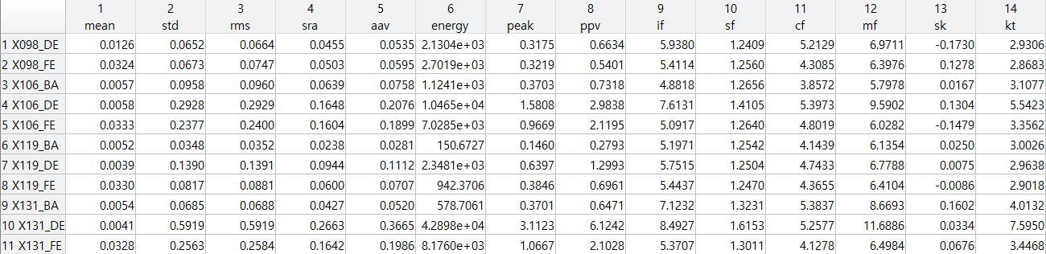

3.2. Prominent feature differences in time domain of each signal in DE data

|  |  |
| --- | --- |
| **Standard deviation** | **RMS** |
|  |  |

|  |  |
| --- | --- |
| **Impulse factor** | **Skewness** |
|  |  |

**4. Frequency domain**

4.1. Frequency domain features

4.2. Prominent feature differences in frequency domain of each signal in DE data

|  |  |
| --- | --- |
|  |  |

4.3. FFT result of each data

|  |  |
| --- | --- |
|  |  |
|  |  |

4.3. Power spectrum density

|  |  |
| --- | --- |
|  |  |
|  |  |

**5. Time-Frequency domain (STFT)**

5.1. Normal data

|  |  |
| --- | --- |
|  |  |

5.2. Outer crack data

|  |  |
| --- | --- |
|  |  |

5.3. Inner crack data

|  |  |
| --- | --- |
|  |  |

5.4. Ball fault data

|  |  |
| --- | --- |
|  |  |

**6. Envelop Extraction**

**6.1. extraction & envelope spectrum**

|  |  |
| --- | --- |
| Envelope | Envelope spectrum |
|  |  |
|  |  |
|  |  |
|  |  |

**6.2. Checking harmonics**

|  |  |
| --- | --- |
| Normal data ( FTF ) | Outer data ( BPFO ) |
|  |  |
| Inner data ( BPFI ) | Ball data ( BSF ) |
|  |  |

**7. Kurtogram & Spectral kurtosis**

**7.1. Normal data**

|  |  |
| --- | --- |
|  |  |

|  |
| --- |
|  |

**7.2. Outer fault data**

|  |  |
| --- | --- |
|  |  |

|  |
| --- |
|  |

**7.3. Inner fault data**

|  |  |
| --- | --- |
|  |  |

|  |
| --- |
|  |

**7.4. Ball fault data**

|  |  |
| --- | --- |
|  |  |

|  |
| --- |
|  |

**8. Bandpass filter**

|  |  |
| --- | --- |
| Raw signal & Envelop | Filtered signal & Envelop |
|  |  |

Based on the kurtogram result of ball fault data, we can design band pass filter considering the center frequency and bandwidth of that signal since the signal contains many signals with influential frequencies.

**9. Discussion and analysis**

9.1. Time domain analysis

**-** If a fault exists in the bearing, it can be confirmed that the amplitude of the abnormal data except fault has increased overall compared to the signal of normal data. In addition, it fault exists, there will be relatively many signals that deviate from the average value, and when comparing the standard deviation, the corresponding result can also be confirmed.

**-**  Vibration signals are generally composed of signals of many frequencies that occur simultaneously. Since the RMS value considers the time history of the wave and provides amplitude values directly related to the energy content, it is most relevant to the breaking ability of the vibration. The RMS value of the vibration signal is calculated as the square root of the value integrated over the entire frequency range by obtaining the power spectrum of each sine wave. Based on this, it is possible to determine that the risk of destruction is high in the order of normal – ball fault – inner fault – outer fault.

|  |  |
| --- | --- |
|  |  |

9.2. Frequency domain analysis

- Considering the FFT results, only certain frequencies of normal signal below 2,000 [Hz] are observed, and no more signals of frequencies over 2,000 are observed. On the other hand, in the case of a bearing signal having a crack defect, it is possible to confirm that higher frequency signals and signals of various frequencies are observed. If interpreted in the frequency domain, if the magnitude of signals above a specific frequency is observed with large magnitude, it can be judged as defective factor.

- In addition, referring the STFT result in **5. Time-Frequency domain** below, it can be seen that many signals of a frequency higher than normal value are observed in the case of data with fault.

9.3. Envelop analysis

- The signal we got consists of the product of the modulating signal and the carrier signal. We have to get envelop of such signals to check the harmonics of particular frequencies such as BPFI, BPFO, BSF. **6.1. extraction & envelope spectrum** shows the results of envelop extraction of each signals and the FFT result of extracted envelops. And following **6.2. Checking harmonics** shows the harmonics between each signal and the related frequency. (e.g. Outer fault envelop - BPFO) As we can check the results in that figure, the FFT results of envelop of outer fault signal and inner fault signal get harmonics with BPFO, BPFI sequentially. In conclusion, the aforementioned two signals (outer fault, inner fault) can be concluded by checking the harmonics with a specific frequency to determine which of the internal elements of the bearing is due to which defect. Unlike the previous signals where feature points are clearly detected, it seems that preprocessing is required in the case of ball fault since the signal from that case contains many influential frequency components as we can see in the FFT result in **6.1. extraction & envelope spectrum** and the envelop of raw signal in **8. Bandpass implementation.**

9.4. Analysis of kurtogram & spectral kurtosis

- The value of spectral kurtosis is large in frequency bands where the impulsive bearing fault signal is dominant, and effectively zero where the spectrum is dominated by stationary components. There can be several factors if kurtosis value is zero. One of the factors is that a constant frequency was repeatedly measured with little influence from noise. As we can see the form of signal in time domain, the case of inner fault and other fault can be confirmed that the periodic shape is repeated, and even though the fault exists, the kurtosis seems to have become 0.